**DAYANANDA SAGAR COLLEGE OF ENGINEERING**

**(An Autonomous Institute affiliated to VTU, Belagavi – 590018, Approved by AICTE & ISO 9001:2008 Certified)**

**Accredited by National Assessment & Accreditation Council (NAAC) with ‘A’ grade & NBA**

 

**SYNOPSIS**

***SOLAR POWER INVERTER***

Under Bachelor of Engineering in Electrical & Electronics

***Submitted by***

**Abhishek Kumar Tiwari 1DS19EE002**

**Akhilesh Kumar 1DS19EE006**

**Aniket Bharti 1DS19EE009**

**Mukul Mayur 1DS19EE050**

Under the Guidance of

✓

**Dr. M. Balamurugan**

**DEPARTMENT OF ELECTRICAL AND ELECTRONICS ENGINEERING**

**DAYANANDA SAGAR COLLEGE OF ENGINEERING**

**Shavige Malleshwara Hills, Kumaraswamy Layout**

**Bengaluru-560078**

**2022-23**

**ABSTRACT**

To use the multiple renewable energy sources for single-phase AC applications with an H6 converter topology. Dual input DC-DC buck-boost converters that integrate the solar panel and a battery will regulate the required output DC voltage. Furthermore, for the AC applications of having small power and High power, the H6 topology of single-phase transformerless inverter is preferred because of less leakage current. To validate the proposed technique's feasibility, the MATLAB simulation is performed for the whole process and a prototype is to be designed that validates the converter's results and performance. The simulation is to be carried out in MATLAB/Simulink software.

**(1)Importance of the Solar Power Inverter in the present day scenario:**

There are two types of sources for electrical power generation.One is conventional and other is non-conventional.Today to generate most of electrical power conventional sources like coal,gas,nuclear power generators are used, which is not good for the environment.So some of the electrical power should be generated by non-conventional energy like solar,wind.With the continuously reducing the cost of PV power generation and the further need of energy crisis, PV power generation technology obtains more and more application.Importances in the present day scenario are pollution free energy, reduction in greenhouse gasses,energy reproduction in remote locations.

**Literature Survey:**

**\*Boost Converter With MPPT and PWM Inverter For Photovoltaic System.**

*Tejan L1* and Divya K Pai1 *Corresponding Author: Tejan L,teja77units@gmail.coma*

*Volume-7, Issue-3, March 2020*

This paper presents boost converter with maximum power point tracking technique for photovoltaic system to extract maximum power from solar panel, and the system is connected with battery storage system, and cascaded with PWM inverter along with an RLC second order passive filter which outputs a stable AC voltage, which is not possible in traditional PV inverter system.

**\*Design of Solar Power Inverter**

*GAURAV ARORA, NEHA AGGARWAL, DEBOJYOTI SEN, PRAJJWAL SINGH Assistant Professor, IMSEC Ghaziabad* *.International Advanced Research Journal in Science, Engineering and Technology (IARJSET)* *(Vol. 3, No. 1, April 2020, 12-19)*

The high energy demand and the constant depletion of fossil fuels lead us to shift our focus to renewable energy sources which are not only the future unlimited source of energy, it is also eco-friendly and viable for the environment. Solar energy is the oldest form of Renewable Energy. This paper focuses on the design of Solar Inverter which is required to run AC loads which is mostly used for consumable purposes. The power output of the designed inverter is 100W, input voltage is 12V ,Output is 220 V, 50Hz square wave output.

**\*Solar energy: Potential and future prospects**

*Kabir, et al., "Solar energy: Potential and future prospects," Renewable and Sustainable Energy Reviews, 2018, 82, pp.894-900*

The development of novel solar power technologies is considered to be one of many key solutions toward fulfilling a worldwide increasing demand for energy. Rapid growth within the field of solar technologies is nonetheless facing various technical barriers, such as low solar cell efficiencies, low performing balance-of-systems (BOS), economic hindrances (e.g., high upfront costs and a lack of financing mechanisms), and institutional obstacles (e.g., inadequate infrastructure and a shortage of skilled manpower). The merits and demerits of solar energy technologies are both discussed in this article. A number of technical problems affecting renewable energy research are also highlighted, along with beneficial interactions between regulation policy frameworks and their future prospects. In order to help open novel routes with regard to solar energy research and practices, a future roadmap for the field of solar research is discussed.

**Gap Analysis:**

In the above papers authors have used step-up transformers in their inverters. This paper solves this problem by using a transformerless inverter using the H-6 topology.

* Transformerless inverters are generally more efficient than conventional inverters because they are able to avoid internal energy losses and extra component costs.
* Due to the absence of a transformer, transformerless inverters are light, compact, and relatively cheaper than conventional inverters.
* Since transformerless inverters use electronic switching rather than mechanical switching, the amount of heat and buzzes produced by standard inverters is greatly reduced. This, in some cases, removes the need for cooling fans.
* Traditional inverters work through only one powerpoint, which means panels that are performing at lower frequencies will lower DC output for the entire system. But with transformerless inverters, solar panels can be installed in two different directions (i.e. north and west) on the same rooftop and generate DC output at separate peak hours with optimal effects.

**(3)Objectives :**

* The main aim of the transformer-less inverter is to eliminate the losses taking place in inverter due to the presence of transformer by utilizing the high voltage power electronic switches, and as an outcome, it also leads to decrease in size, weight and cost of the inverter system.

* The MPPT charge controller ensures that the loads receive maximum current to be used (by quickly charging the battery). Maximum power point could be understood as an ideal voltage at which the maximum power is delivered to the loads, with minimum losses. This is also commonly referred to as peak power voltage.

**(4) Methodology:**

This system has two distributed generation units and those are battery and Photovoltaic energy. When the PV source is available, it charges the battery as well as provides energy to the load. When PV source is not available or less solar irradiation then the batteries will charge through a secondary AC source which is converted to DC by the help of a rectifier circuit.

The output power source is approx 100 watts.Dual DC-DC buck-boost converter is used to increase the DC voltage with integration of solar panel and batteries.

Further for AC application H6 or H5 topology of single-phase transformerless inverter is preferred because of less leakage current.which help to reduce weight of the solar inverter.

To validate the proposed technique's feasibility, the MATLAB simulation is performed for the whole process and a prototype is to be designed that validates the converter's results and performance. The simulation is to be carried out in MATLAB/Simulink software.

**Maximum Power Point Tracking (MPPT):**

MPPT works on Maximum power transfer theorem which states that output power will be maximum if input parameters and output parameters are matched. The principle of working is as voltage and current of PV cells will be varying based on solar parameters the MPPT will be designed in such a way that it finds maximum power point of cell for different voltage and current by estimating power and gives signal to control boost converter to work in maximum efficiency condition.

**Buck-Boost Converter:**

The bidirectional Buck-Boost converter topology is composed of an inductor, two capacitors, and two switching transistors. The diode of the switching transistor plays an important part in the circuit design, allowing the current to flow bidirectionally from the DC link to the battery storage device and vice versa.

**H6 Type Single Phase Transformerless Inverter:**

After regulating the required output voltage, the buck-boost converter feeds it to the single-phase transformerless inverter, converting this DC voltage into AC for AC power applications.

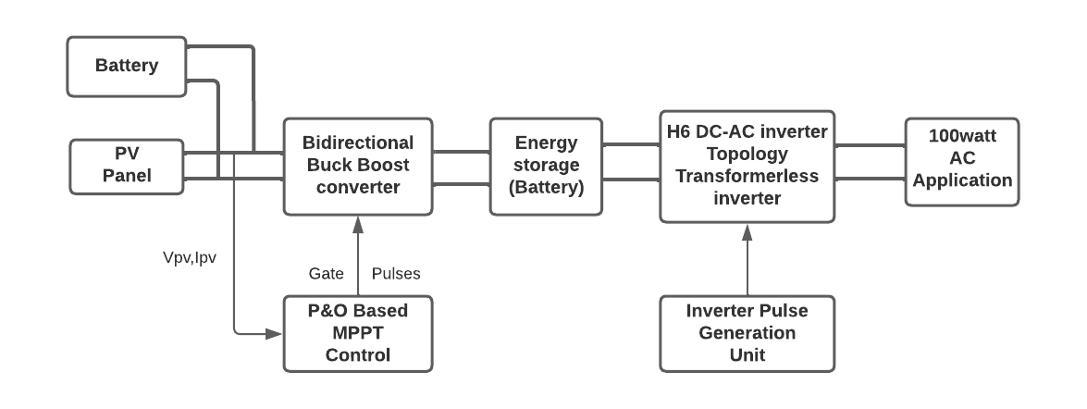

**BLOCK DIAGRAM**

**(5)Applications:**

**DC Power Source Utilization**

An inverter converts the Dc electricity from sources such as batteries,solar panels or cells to Ac electricity.The electricity can be any required voltages;in particular it can operate AC equipment designed for mains operation,or rectified to produce DC at any desired voltage.

**Uninterruptible Power Supply**

An uninterruptible power supply(UPS) uses batteries and an inverter to supply AC power when main power is not available when main power is restored, a rectifier supplies DC power to recharge the batteries(Automatically).

**Efficiency**

These are best suitable for residential and commercial arrangements wherein the solar panels face different directions, hence combating inefficiencies created due to shading. It is costlier than string inverters but is the perfect solution for installations where there is a disparity in the amount of sunlight received by individual solar panels.

**Transformerless Inverter**

Transformerless inverters are much lighter and compact compared to the transformer-based inverters with transformerless inverters energy losses are avoided as well as extra components costs, making it more affordable. Transformerless inverters use electronic (rather than mechanical) switching, thereby reducing the amount of heat generated by the inverter.

**References:**

1**.Boost Converter With MPPT and PWM Inverter For Photovoltaic Systems.**

*Tejan L1* and Divya K Pai1 *Corresponding Author: Tejan L,teja77units@gmail.coma*

*Volume-7, Issue-3, March 2020*

2.**Design of Solar Power Inverter**

*GAURAV ARORA, NEHA AGGARWAL, DEBOJYOTI SEN, PRAJJWAL SINGH Assistant Professor, IMSEC Ghaziabad* *.International Advanced Research Journal in Science, Engineering and Technology (IARJSET)* *(Vol. 3, No. 1, April 2020, 12-19)*

3.**Solar energy: Potential and future prospects**

*Kabir, et al., "Solar energy: Potential and future prospects," Renewable and Sustainable Energy Reviews, 2018, 82, pp.894-900*

4Schuss, et al., "Impacts on the Output Power of Photovoltaics on Top of Electric and Hybrid Electric Vehicles," in IEEE Transactions on Instrumentation and Measurement, vol. 69, no. 5, pp. 2449-2458, May 2020, DOI: 10.1109/TIM.2019.2962850.

5 Z. Q. Zhu and S. Cai, "Hybrid excited permanent magnet machines for electric and hybrid electric vehicles," in CES Transactions on Electrical Machines and Systems, vol. 3, no. 3, pp. 233-247, Sept. 2019, DOI: 10.30941/CESTEMS.2019.000321

6.S. Hussain et al., "Simulative Analysis of Power Conversion System for Hybrid Electric Vehicles Based on Dual Input Sources Including Charging From Solar Panel," Pakistan J Engg & Tech, vol. 3, no. 03, pp. 14-19, Dec. 2020.

7.M. Nasir, H. A. Khan, A. Hussain, L. Mateen and N. A. Zaffar, "Solar PV-Based Scalable DC Microgrid for Rural Electrification in Developing Regions," in IEEE Transactions on Sustainable Energy, vol. 9, no. 1, pp. 390-399, Jan. 2018.

PO’s mapping:

|  |  |  |  |  |  |  |  |  |  |  |  |  |  |  |  |  |
| --- | --- | --- | --- | --- | --- | --- | --- | --- | --- | --- | --- | --- | --- | --- | --- | --- |
| **Group No.** | **Project Title** | **PO1** | **PO2** | **PO3** | **PO4** | **PO5** | **PO6** | **PO7** | **PO8** | **PO9** | **PO**  **10** | **PO**  **11** | **PO**  **12** | **PSO1** | **PSO2** | **PSO3** |
|  |  |  |  |  |  |  |  |  |  |  |  |  |  |  |  |  |

Signature of the Students: Signature of Internal Guide with date